**Part 1**

I started with the Quickstart guide for JavaScript and installed the javascript SDK and created the index.html file using BBedit.

***Feature Flag: Implement a flag around a specific new feature. You should be able to demonstrate releasing the feature by toggling the flag on, and rolling it back by toggling it off.***

The initial flag was created and I renamed it to the Homework Flag. I toggled the flag On and launched the index.html file. The flag value was set to true and displayed the status line with the background of green.

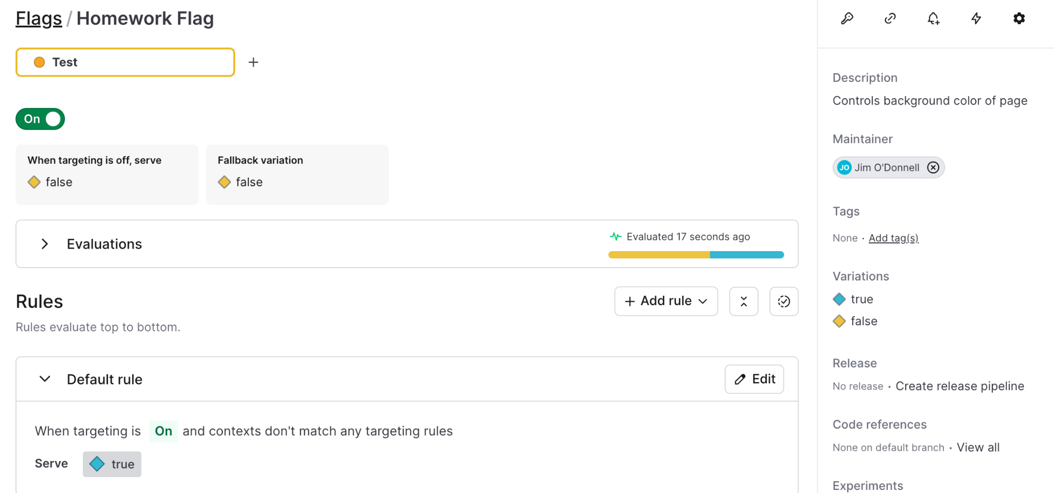

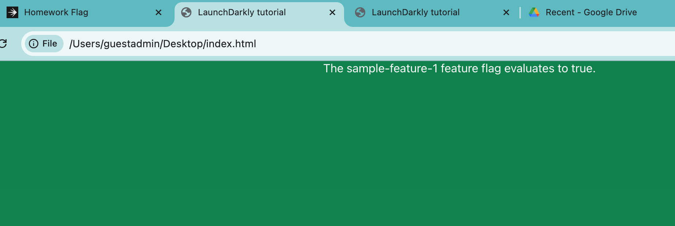

I set the toggle to off and the flag value was set to false automatically without a page refresh.

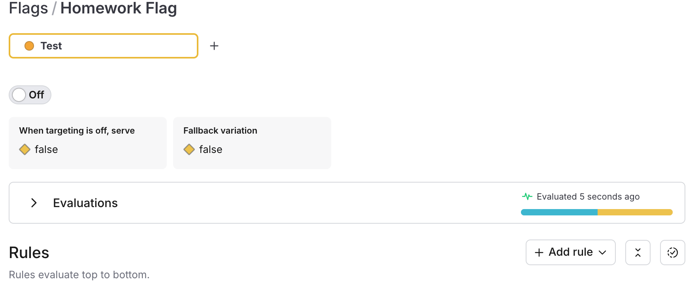

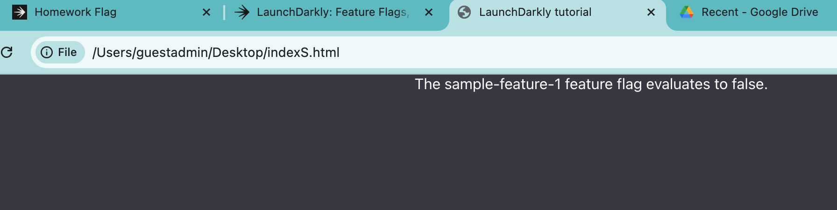

***Instant releases/rollbacks: Implement a “listener”, such that when the flag is toggled, the application instantly switches to the new/old code (i.e. no page reload required)***

Within the index.html ldclient.on(‘change’, render); is used

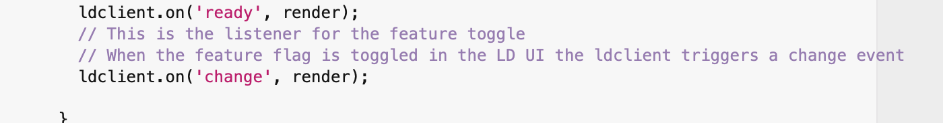

***Remediate: Use a trigger to turn off a problematic feature (can be done manually, e.g. via curl, or via a browser).***

The instructions say to create a trigger and the online documentation states to use the Flag’s Settings page to do so. Using the free trial version the settings page doesn't have a "triggers" section in the UI. The [doc page](https://apidocs.launchdarkly.com/tag/Flag-triggers) for creating a Trigger via API states triggers are available with an Enterprise plan and to contact sales to upgrade my plan.

I’d like to confirm my understanding and if I'm correct the trigger requirement can't be completed on the free trial plan.

The intent of this Trigger is to generate a URL or API call using the curl command and execute the trigger from the customer’s monitoring solution to control features based on application or infrastructure performance metrics.

**Part 2**

***Context Attributes: Create context attributes of your choosing you will use these to target your feature release.***

Created 3 different html files with a different user for each to generate the below contexts.

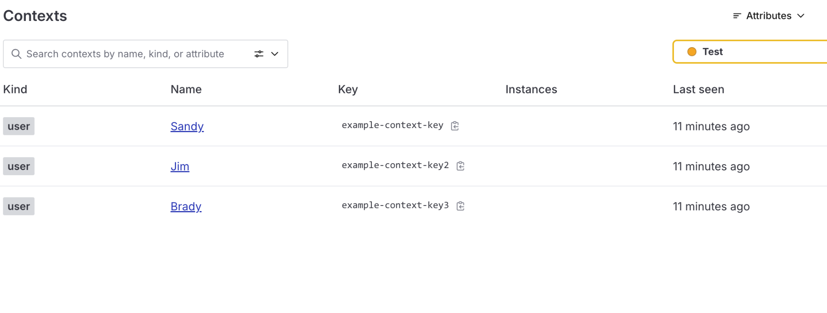

I added a context for Brady with country = Mexico in the indexB.html file.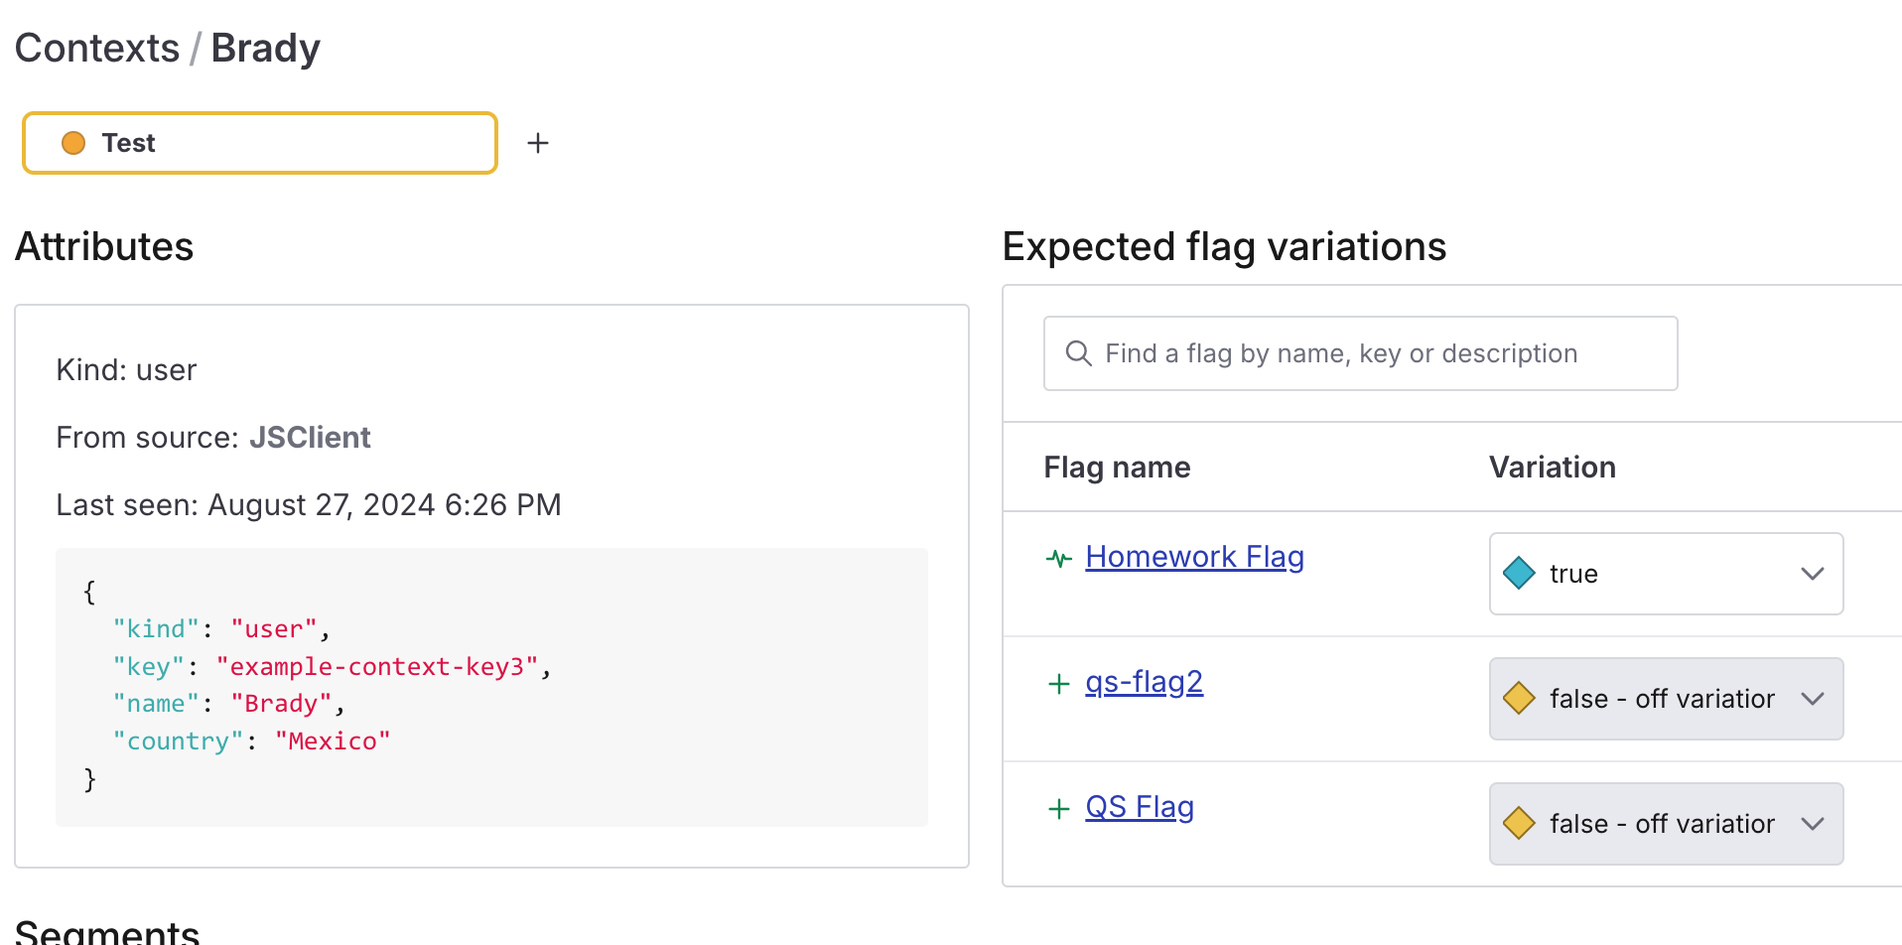

I added a context for Jim with country = United States in the index.html file.

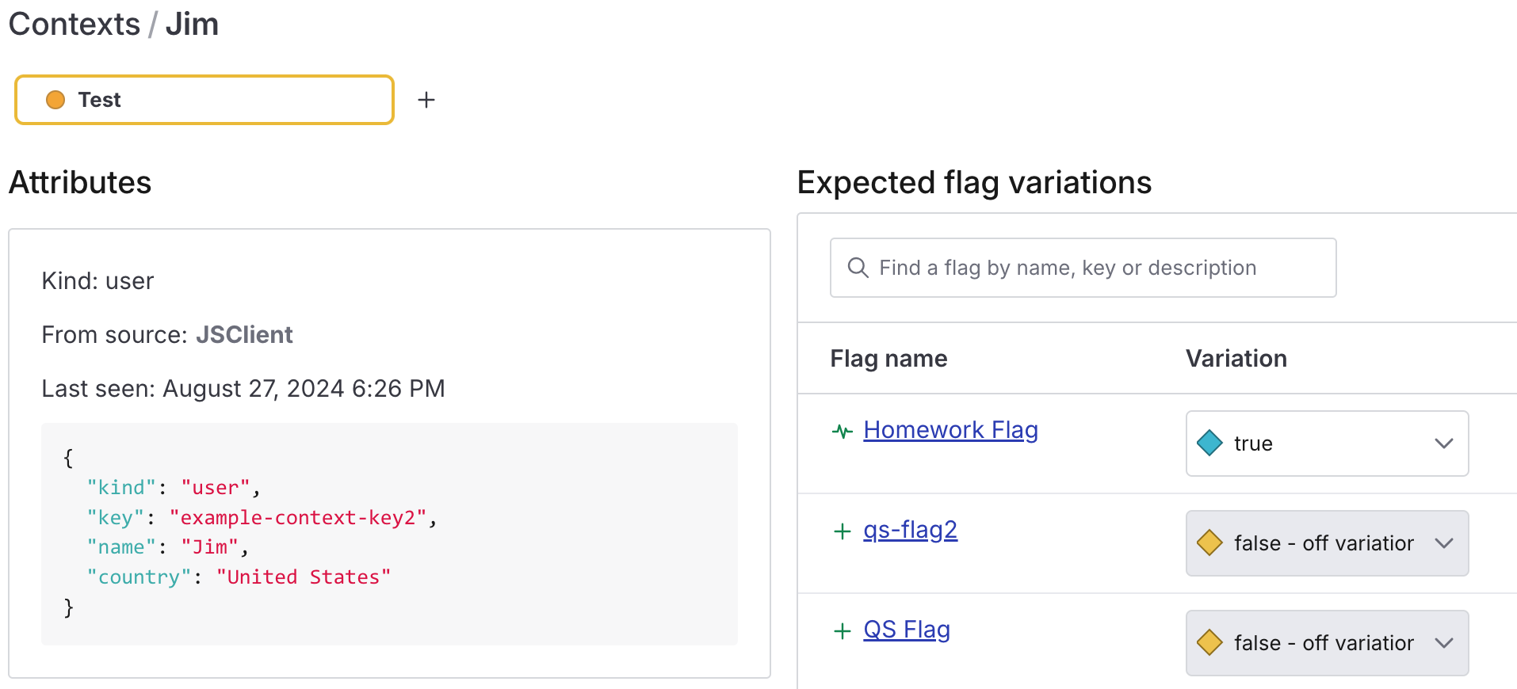

I added a context for Sandy with country = Canada in the indexS.html file.

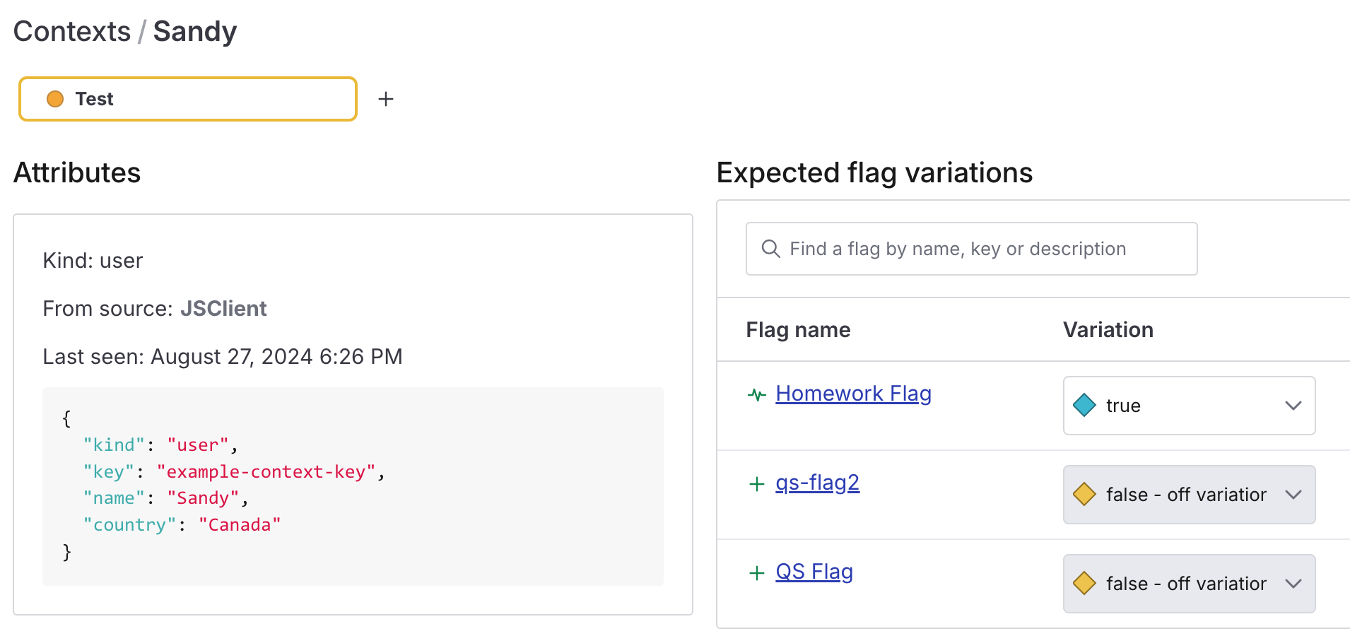

***Targeting: Demonstrate both individual targeting and rule-based targeting.***

*Individual Targeting*

Created a rule for 1 individual target. If user = Jim set the feature to false and change the background to gray.

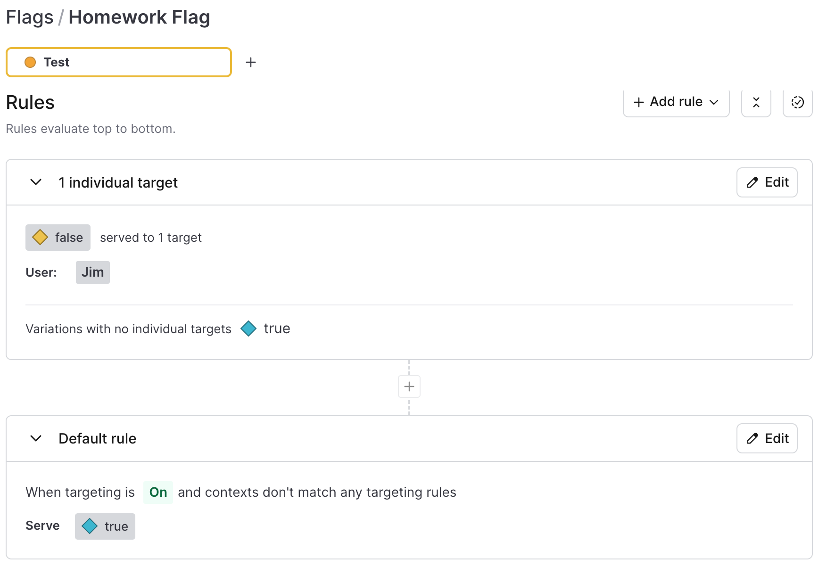

Result for above rule with correct background color when flag set to false on user “Jim” evaluation.

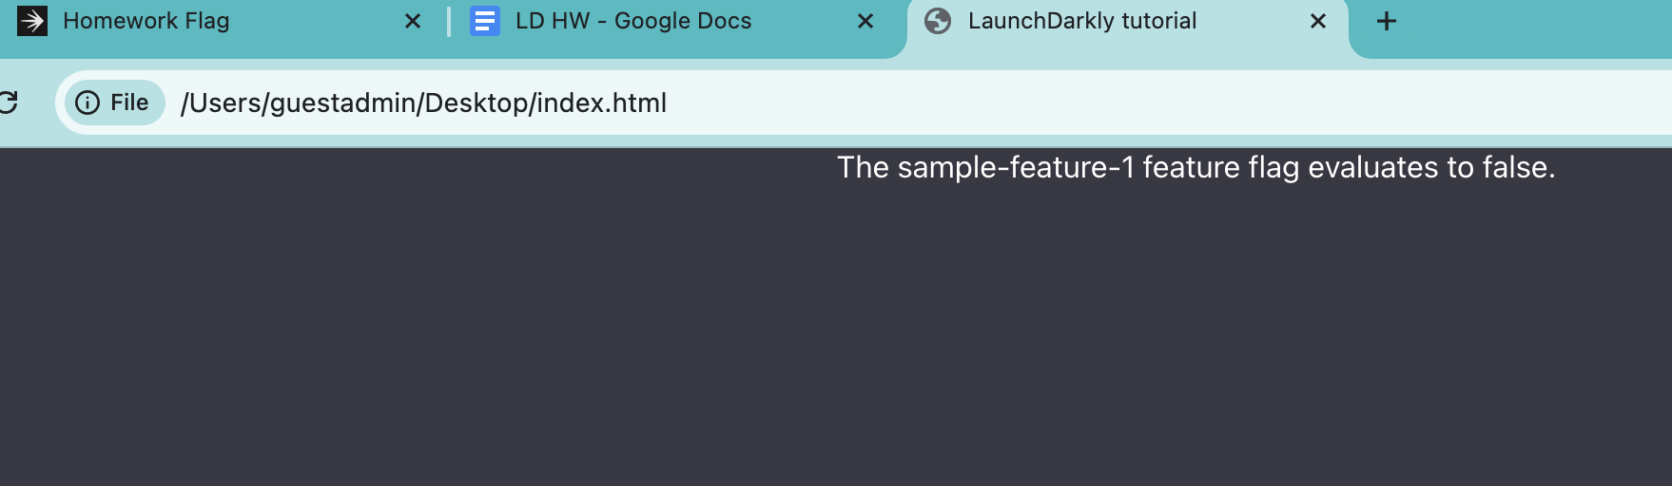

Context from index.html

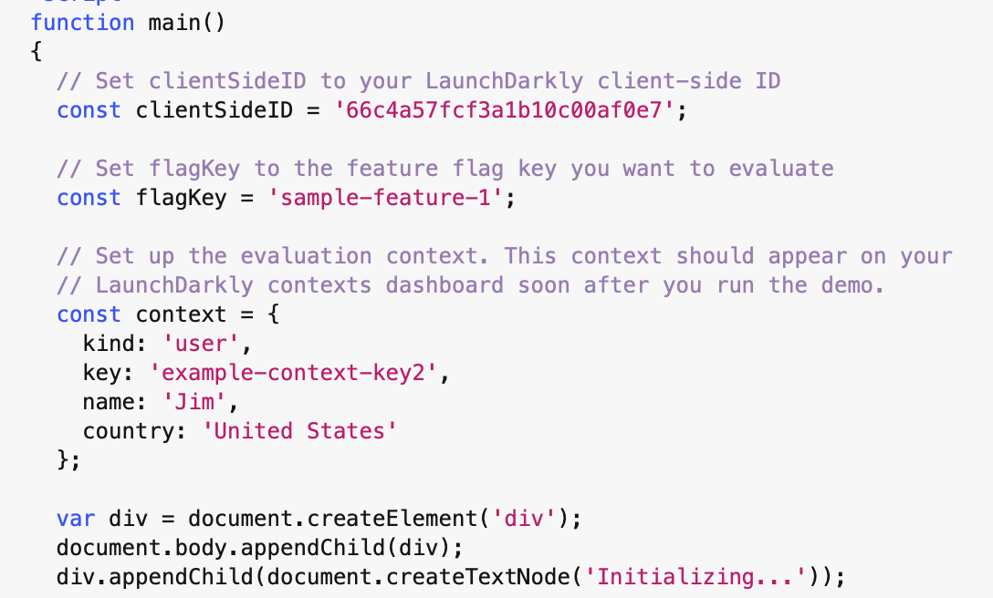

*Rule-based targeting*

I created a custom rule targeting the user country. If the user country is one of “United States, Canada” set Rollout to true and turn the page background color to green.

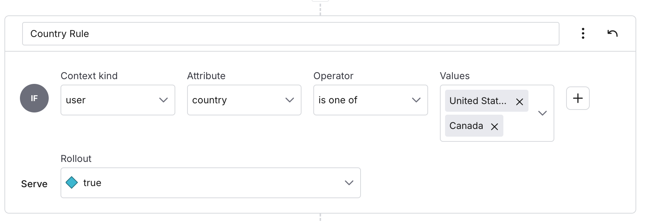

And if contexts don’t match any targeting rules set the feature flag to false and change page background to gray.

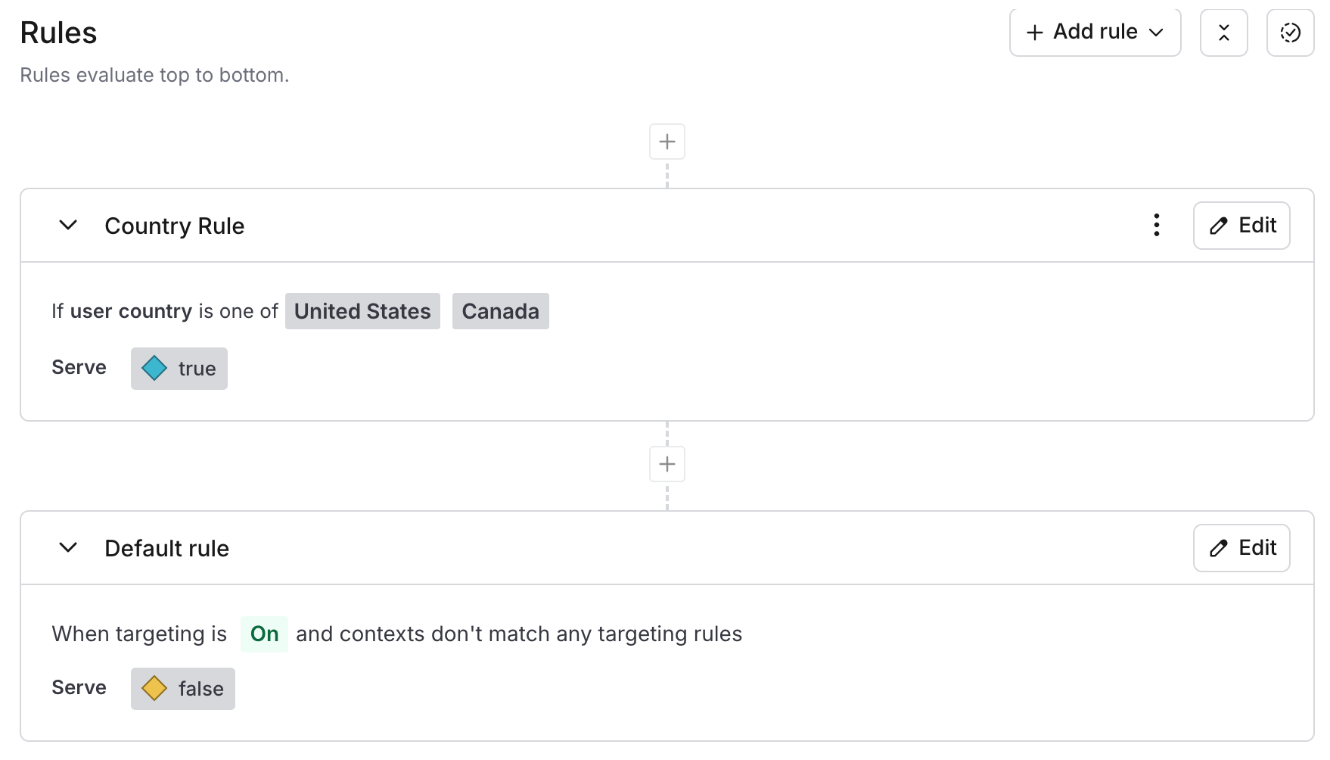

I used the user = Brady with country = Mexico to force a false result when running indexB.html

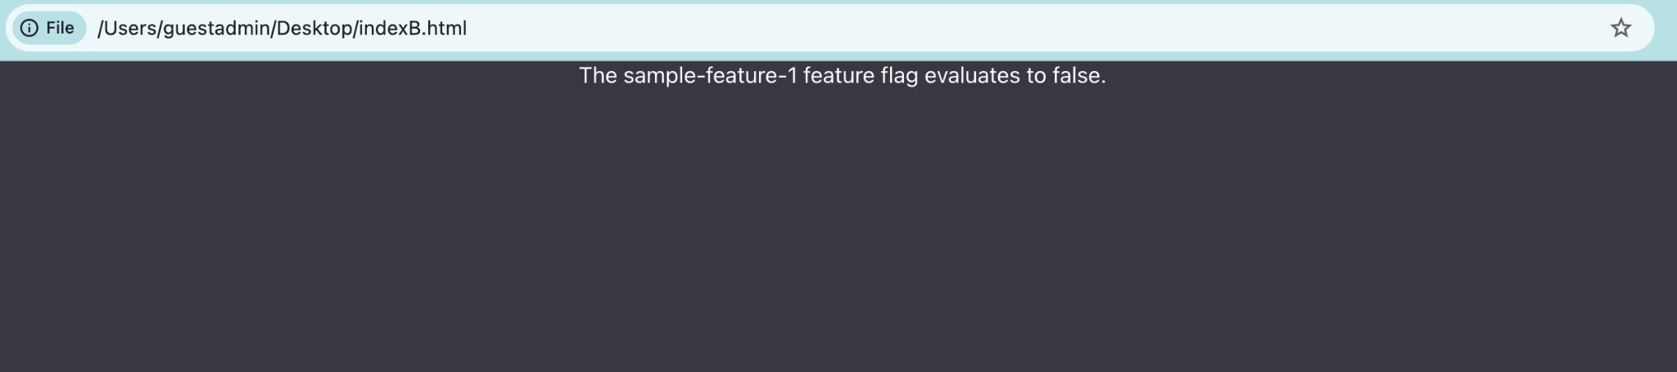

I then tested with user = Sandy with Country = Canada to create a true result when running indexS.html 